
MESA DAY 2025-2026

SCIENCE LAB BOOK REQUIREMENT
CRIME SCENE SCIENCE
MIDDLE SCHOOL TEMPLATE

NAMES:____________________________________________
(team member names)

SCHOOL:___________________________________________

CENTER: ___________________________________________

LEVEL (circle one): 6th gr 7/8th gr

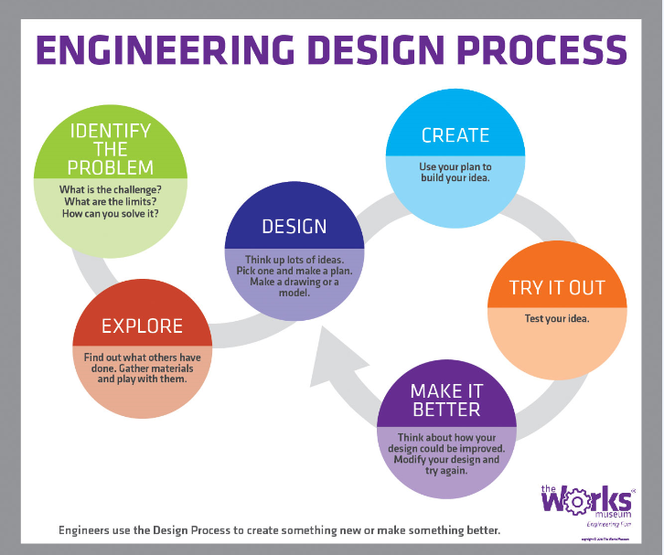

*Changes, if any, are highlighted in “yellow.”

USING ONE TO TWO SENTENCES, ANSWER THE FOLLOWING QUESTIONS:

What are the 6 major steps to solving a crime scene?

What are the 3 basic fingerprint pattern types, and how are they described?

Lift your own fingerprint using a pencil and tape. Please draw a representation of your own fingerprint, and identify the fingerprint pattern in your electronic science journal.

- SKETCH of DNA with labeled parts (Sketches can be hand drawn or computer generated)

Adenine
Thymine
Guanine
Cytosine
Sugar phosphate backbone

- DEFINE THE FOLLOWING FORENSICS TERMS AND PROVIDE ONE (1) EXAMPLE FOR EACH OF THE FOLLOWING:

Trace evidence

Locard’s Exchange Principle

Testimonial evidence versus Physical evidence
- MEASUREMENTS & ANALYSIS IN FORENSICS. ANSWER THE FOLLOWING QUESTIONS BELOW USING TWO TO THREE SENTENCES.
- *For the math answer, you must include the steps you took to get your answer. This includes writing down calculations, diagrams, equations, or explanations [MUST be original work]

When measuring a footprint, what tools would you use, and what could it help estimate?

If a footprint is 28 centimeters long, approximately how tall is the person? Please show all your work for your answer.*

How can hairs or fibers be identified under a microscope?

- SKETCH OF MICROSCOPE WITH LABELED PARTS (SKETCHES CAN BE HAND DRAWN OR COMPUTER GENERATED [MUST BE ORIGINAL WORK])

Arm
Objective Lens
On/Off Switch
Stage
Head
Slide Holder Clips Illuminator/Light Source
Ocular Lens/Eyepiece
Focus adjustment knob
Base

