
MESA DAY 2025-2026
Revised 11/12/2025

SCIENCE JOURNAL REQUIREMENT
BIO BREAKTHROUGH
HIGH SCHOOL TEMPLATE

NAMES:____________________________________________
(team member names)

SCHOOL:___________________________________________

CENTER: ___________________________________________

LEVEL (circle one): 9/10th gr 11/12th gr

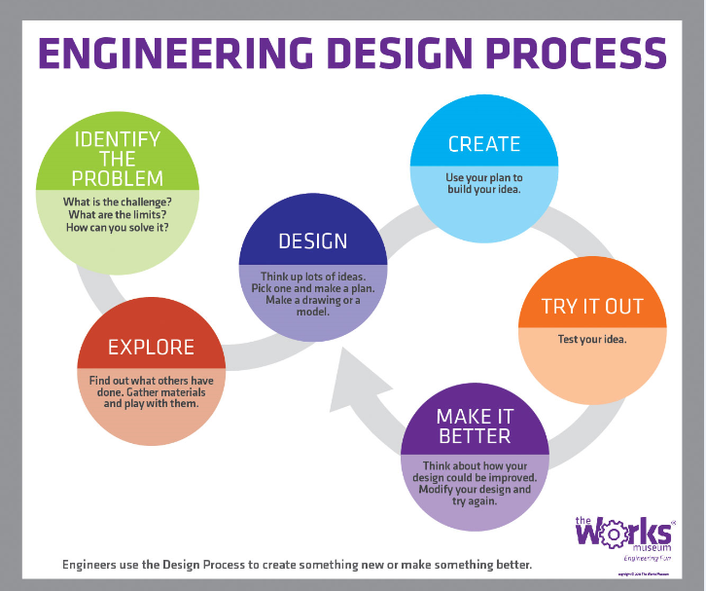

SECTION 1: Transcription & Translation
Answer each question in 2–3 complete sentences.
1. What is transcription?

2. What is translation?

3. What are the steps of transcription?

SECTION 2: CRISPR Overview
Answer each question in 2–3 complete sentences.
4. Define the following scientific terms:
- Gene Editing:___________________________________________________________
- Guide RNA (gRNA):______________________________________________________
- Cas9 Protein:___________________________________________________________
5. What is CRISPR-Cas9?

4. What is CRISPR-Cas9?

5. How does CRISPR edit genes?

SECTION 3: CRISPR Practice — Transcription & Translation

Example Puzzle (Solved)
Starting DNA Sequence:
ATG GGA TCC TAC CAT CGA ATC GAA TCG GTT AAG
a. Targeted DNA sequence:
Targeted sequence: TAG CAT CGA ATC
Edited DNA: ATG GGA TCC TAC CAT CGA ATC GGT TAA
b. Transcribe to mRNA:
AUG GUA GCU UAG
c. Translate to amino acids:
Start from start codon: Met – Val –Ala – Stop
d. Role of Protein:
Proteins like this may play a role in signaling or transporting molecules inside the cell.

Practice Puzzle (Using the codon chart below, solve the following practice puzzle)
6. Starting DNA Sequence:
TAC GGT ACC TAG CGA TAC CGG ATT TAG CTT ACG ATT TCC AGG CTA GGC TTA ACC

a. Identify the targeted DNA sequence:

b. Transcribe the edited DNA sequence into mRNA:

c. Underline the start codon and translate the mRNA into its amino acid sequence:
Use this chart to help decode mRNA into amino acids:

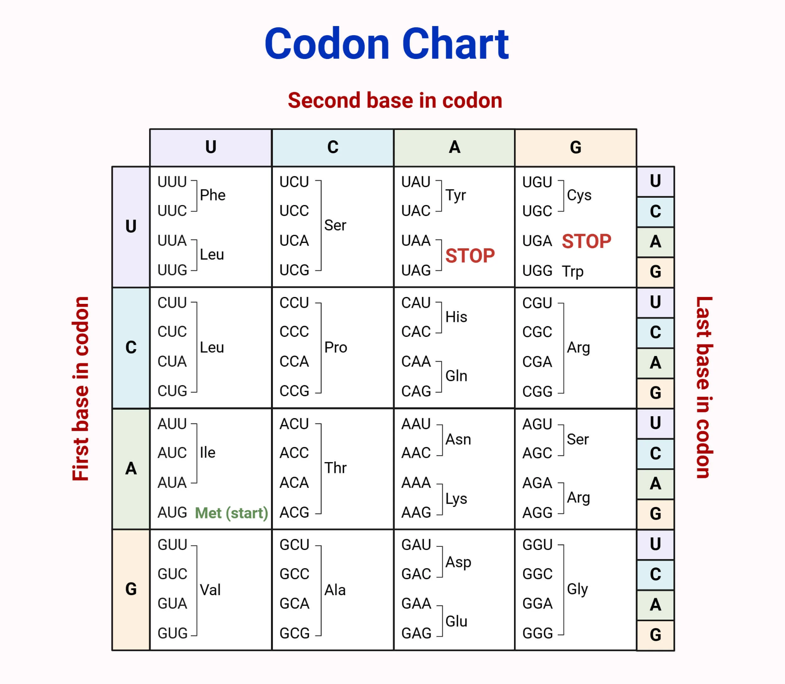

SECTION 4: Real-World Connection
Answer the following in 4–5 complete sentences.
7. Describe how gene editing using CRISPR can impact an under-resourced community affected by a specific disease or disorder.

END OF SCIENCE JOURNAL
This document will be evaluated based on clarity, completeness, and alignment with Bio Breakthrough rubric criteria. Be sure to proofread your answers before submission.

